

YEAR 12 CHEMISTRY – 3BCHE

ANSWERS TO TEST 4 - 2015

Organic Chemistry

ANSWERS

MULTIPLE CHOICE ANSWER SHEET

Instruction

For each question shade the box to indicate your answer.
Use only a blue or black pen to shade the boxes.

For example, if b is your answer: a b c d

If you make a mistake, place a cross through that square then shade your new answer.
Do not erase or use correction fluid.

For example, if b is a mistake and d is your answer: a b c d

If you then want to use your first answer b, cross out d and then circle b.

a b c d

Marks will not be deducted for incorrect answers. No marks will be given if more than one answer is completed for

Questions 1-10

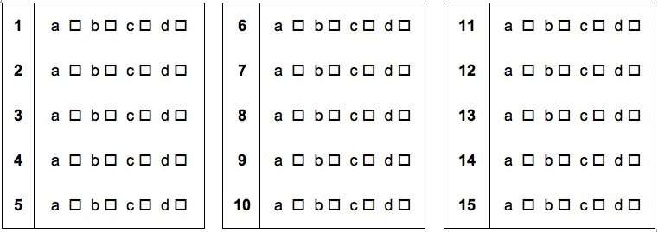

PART 2 : Short Answers (30 marks)

Write your answers in the space provided.

1. Complete the following table by naming or drawing the structural formula

Structural formula | Name
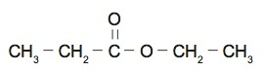 | Ethyl propanoate
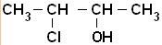 | 3-chlorobutan-2-ol
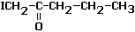 | 1-iodo-pentan-2-one
(1 mark each)

2. Apart from acidified sodium permanganate (KMnO₄) and potassium dichromate (K₂Cr₂O₇) solutions, chromic acid (H₂CrO₄) may also be used to oxidise alcohols.

In an experiment, Timmy added a few drops of chromic acid solution to a 5 mL sample of warm
butan-1-ol and the colour of the acid solution was observed to change from yellow to deep green. As the oxidation number of the chromium atom in chromic acid is the same as that of potassium dichromate, it can be assumed that the resultant green colour was due to the presence of chromium (III) ions in the final mixture.

Use the information provided to complete the table below:

Oxidation half equation | CH₃CH₂CH₂CH₂OH + H₂O → CH₃CH₂CH₂COOH + 4H⁺ + 4è
Reduction half equation | 6H⁺ + H₂CrO₄ + 3è → Cr³⁺ + 4H₂O
Overall redox equation | 3CH₃CH₂CH₂CH₂OH + 12H⁺ + 4H₂CrO₄ → 3CH₃CH₂CH₂COOH + 4Cr³⁺ + 13H₂O
(1 mark each)
3. Recent research being done in Australia has led to the conclusion that people who suffer from Chronic Fatigue Syndrome (CFIDS), especially those with more neurological symptoms, may actually have a treatable amino acid deficiency. At the 1998 CFIDS conference in Sydney, doctors from Newcastle University in Callaghan, Australia, presented their intriguing discovery that a substantial number of CFIDS patients have a deficiency in the amino acid, serine.

One form of serine, L-serine has the structural formula

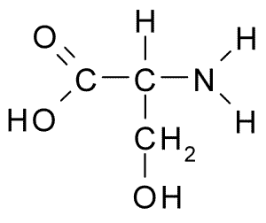

carboxylic acid
amine

alcohol

- On the structural formula above, circle and name any two (2) functional groups.
(1 mark each for any 2 groups)

(b) State the likely observation when a few drops of acidified potassium permanganate is added to a small sample of L-serine that has been heated to an appropriate temperature.

Purple solution turns very pale pink
(1 mark]

(c) In favourable conditions, L-serine, whose chemical formula is HO-CH₂-CH(NH₂)-COOH, can act as a Lowry-Bronsted acid. Write a suitable chemical equation to show this characteristic.

HO-CH₂-CH(NH₂)-COOH + H₂O → HO-CH₂CH(NH₂)-COO⁻ + H₃O⁺
(1 mark)
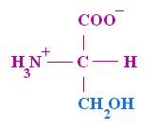
(d) In aqueous solution, L-serine forms a zwitterion with the structure:

(i)

The L-serine zwitterion above can form two (2) different ions:


COOH
(ii) H₂N
(iii)

Which of the structures (i), (ii) or (iii) is mostly found in

Alkaline or basic solutions | Structure (ii)
Acidic solutions | Structure (iii)
(1 mark each)

4. For the following pair of substances, provide details of a chemical test that would allow the two substances to be distinguished from one another. Equations are not required.

Substances | Chemical test | Observations
liquid ethanal (CH₃CHO)  and  ethanoic acid (CH₃COOH) | Choice of  Test 1: Add a few pieces of Mg(s) or a small amount of base such as CaCO₃(s) to both samples.  Or  Test 2: Add a small amount of acidified KMnO₄ to both pre-warmed samples  Or  Test 3: Add a small amount of acidified alcohol to both pre-warmed samples  Or  Test 4:  e.g acid + carbonates/ethanoates/sulfides  acidified K₂Cr₂O₇ etc. | with ethanal :  Test 1: no visible change  Test 2: purple solution turns pale pink.  Test 3: no visible change  with ethanoic acid :  Test 1: solid dissolves and colourless gas forms  Test 2: no visible change.  Test 3: sweet fruity odour

(1 mark for test and 2 marks for observation)

5. At atmospheric pressure, the boiling point of propanone (or acetone), commonly used as a nail polish remover, is 56ºC while propan-1-ol, a known industrial solvent, boils at 97ºC.

Use your knowledge of bonding and intermolecular forces to explain these observations. You may find the use of suitable diagrams useful in your explanation.

In liquid state, propanone molecules attract each other by dipole-dipole attraction.

In liquid state, propan-1-ol molecules attract each other by hydrogen bonds.

Hydrogen bonds are stronger than dipole-dipole hence more energy is needed to overcome the attraction (i.e. higher boiling point).

(1 mark per point above)

6. Elemental analysis of powder found in an abandoned farmhouse shows the presence of carbon, hydrogen, phosphorus and oxygen.

A 5.21 g sample of powder produces 6.32 g of carbon dioxide and 3.24 g of water when combusted completely in excess oxygen gas.

A second, 3.15 g, sample of the same powder is treated with excess nitric acid to convert all of the phosphorus to phosphate ions (PO₄³⁻). The resulting solution is treated with excess calcium nitrate solution to produce 3.37 g of calcium phosphate (Ca₃(PO₄)₂) precipitate.

- Determine the empirical formula of the powder. (11 marks)

n (CO₂) = 6.32 / 44.01 = 0.144 mol (1 mark)

% (C) = (0.144 x 1 x 12.01) x 100 / 5.21 = 33.10% (1 mark)

n (H) = 3.24 / 18.016 x 2 = 0.361 mol (1 mark)

% (H) = (0.361 x 1.008) x 100 / 5.21 = 6.96% (1 mark)

n (Ca₃(PO₄)₂) = 3.37 / 310.18 = 0.01086 mol (1 mark)

n (P) = 2 x 0.0186 = 0.0217 mol (1 mark)

% (P) = (0.0217 x 30.97) x 100 / 3.15 = 21.36% (1 mark)

% (O) 100 – (33.1 + 6.96 + 21.36) = 38.57% (1 mark)

C H P O

Mass % 33.10 6.96 21.36 38.57
______ = _____ ____ _____ _____
M 12.01 1.008 30.97 16

n = 2.756 6.903 0.689 2.41

divide by = 4 10 1 3.5
smallest
(1 mark)

x 2 = 8 20 2 7

(1 mark)

Empirical formula: C₈H₂₀P₂O₇ (1 mark)

(or any other suitable means)

(b) Further analysis of the powder reveals the molar mass of the powder to be 290.18 gmol⁻¹. What is the molecular formula of this powder? (1 mark)

Molecular Mass of E.F = 290.18

Molecular Mass of compound = 290.18 i.e. Molecular Formula = C₈H₂₀P₂O₇

(1 mark)

